BANK LOAN REPORT
Power BI Analytics & Dashboard Project
Project Documentation Report

Prepared by: Siddu Varikuppala
LinkedIn: linkedin.com/in/siddu-data
GitHub: github.com/sidducv0528
Tools Used: Microsoft Power BI | SQL | Microsoft Excel

1. Executive Summary
This project analyzes a portfolio of 38,576 consumer loan applications issued by a bank throughout 2021, using SQL for data extraction and KPI calculation and Microsoft Power BI for interactive dashboard reporting. The objective is to give the bank's leadership a clear, at-a-glance view of lending performance — how much has been lent, how much has been collected, and how healthy the loan book is — while enabling drill-down analysis across time, geography, and borrower characteristics.
The dashboard is built around three connected report pages — Summary, Overview, and Details — backed by a single fact table (bank_loan_data) and a set of SQL queries that define every KPI, month-to-date (MTD) comparison, and categorical breakdown used on the report.
Headline Numbers
Metric | Value
Total Loan Applications | 38,576
Total Funded Amount | $435.76 Million
Total Amount Received | $473.07 Million
Average Interest Rate | 12.05%
Average Debt-to-Income (DTI) | 13.33%
Good Loan Percentage | 86.18%
Bad Loan Percentage (Charged Off) | 13.82%
States Covered | 50
Reporting Period | Jan 2021 – Dec 2021

2. Project Objectives
- Consolidate raw loan-level data into a single trusted source for reporting.
- Design and validate KPI logic in SQL before visualizing it, so every number on the dashboard is traceable to a query.
- Build an interactive, multi-page Power BI report covering summary KPIs, month-over-month trends, and applicant-level detail.
- Classify loans as "Good" (Fully Paid / Current) or "Bad" (Charged Off) to help the bank quantify credit risk.
- Surface actionable insights on lending patterns — by state, purpose, term, home ownership, and employment length — to support credit policy decisions.

3. Tools & Technology Stack
Tool | Purpose
Microsoft Excel | Source data storage (bank_loan_data, 38,576 rows × 24 columns)
SQL | Data querying, KPI calculation, MTD/PMTD comparisons, category breakdowns
Microsoft Power BI | Data modeling, DAX measures, interactive dashboard & visualization
Power Query | Data loading and transformation into the Power BI model

4. Dataset Overview
The core dataset is bank_loan_data, containing one row per loan application with 24 fields spanning borrower demographics, loan terms, and repayment outcomes.
4.1 Key Fields
Field | Description
id / member_id | Unique identifiers for the loan and the borrower
issue_date | Date the loan was issued
loan_status | Fully Paid / Current / Charged Off
loan_amount | Amount funded to the borrower
total_payment | Total amount repaid to date
int_rate | Interest rate on the loan
dti | Debt-to-income ratio of the borrower
term | Loan term — 36 months or 60 months
grade / sub_grade | Internal credit risk grading (A–G)
purpose | Stated reason for the loan (debt consolidation, car, medical, etc.)
home_ownership | RENT / MORTGAGE / OWN / OTHER / NONE
emp_length | Borrower's length of employment
address_state | U.S. state of the borrower
annual_income | Borrower's stated annual income
4.2 Data Scope
- 38,576 loan records across 50 U.S. states
- Loan terms: 36 months and 60 months
- 14 loan purposes and 7 credit grades (A through G)
- Loan issue dates spanning January 2021 to December 2021

5. Methodology
5.1 SQL Layer — KPI Definition
Every metric shown on the dashboard was first defined and validated in SQL against the bank_loan_data table before being rebuilt as a Power BI measure. This ensured the logic (e.g. what counts as a "Good Loan", how MTD vs PMTD periods are filtered) was correct at the source. The full query set is organized into four groups:
- Summary KPIs — Total Applications, Total Funded Amount, Total Amount Received, Average Interest Rate, Average DTI (each with Month-to-Date and Previous-Month-to-Date variants).
- Good Loan metrics — count, percentage, funded amount, and amount received for loans with status "Fully Paid" or "Current".
- Bad Loan metrics — the same four metrics for loans with status "Charged Off".
- Overview breakdowns — applications, funded amount, and amount received grouped by month, state, term, employee length, purpose, and home ownership.
Example — Good Loan Percentage query:
SELECT (COUNT(CASE WHEN loan_status = 'Fully Paid' OR loan_status = 'Current' THEN id END) * 100.0) / COUNT(id) AS Good_Loan_Percentage FROM bank_loan_data;
5.2 Power BI Layer — Modeling & Visualization
- The Excel source was imported and loaded into Power BI via Power Query.
- DAX measures replicated the validated SQL KPI logic (totals, MTD/PMTD, good/bad loan classification).
- Three report pages were designed: Summary (KPI cards + loan-status breakdown), Overview (trend and category analysis), and Details (loan-level grid for drill-through).
- Slicers and cross-filtering were added so every visual responds to state, term, purpose, and grade selections.

6. Dashboard Walkthrough

6.1 Summary Page
The Summary page is the executive landing view. It presents the core lending KPIs as cards, each with a Month-to-Date figure and a Month-over-Month change indicator, alongside a Good Loan vs Bad Loan breakdown and a loan-status distribution.
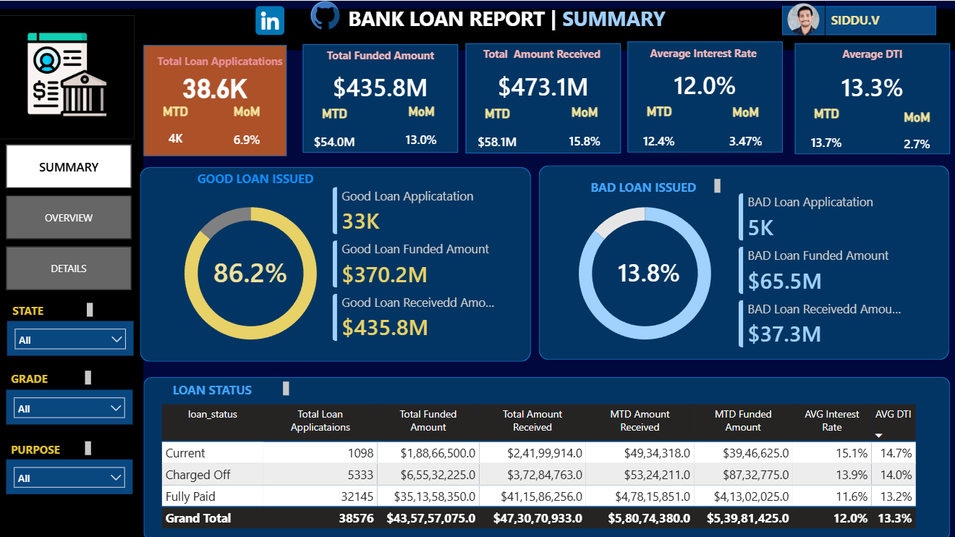
Figure 1 — Summary Page: KPI cards, Good vs Bad Loan split, and loan status breakdown
What it shows
- Total Loan Applications: 38,576 | Total Funded Amount: $435.76M | Total Amount Received: $473.07M
- Average Interest Rate: 12.05% | Average DTI: 13.33%
- Good Loans: 86.18% of applications (33,243 loans) — funded $370.22M, collected $435.79M
- Bad Loans (Charged Off): 13.82% of applications (5,333 loans) — funded $65.53M, collected only $37.28M
- This page lets management immediately see that repayment collections ($473.07M) exceed the amount funded ($435.76M) at the portfolio level, while flagging that Charged Off loans recovered only about 57% of what was funded to them.

6.2 Overview Page
The Overview page breaks the portfolio down across time and borrower dimensions, helping identify where lending volume and risk concentrate.
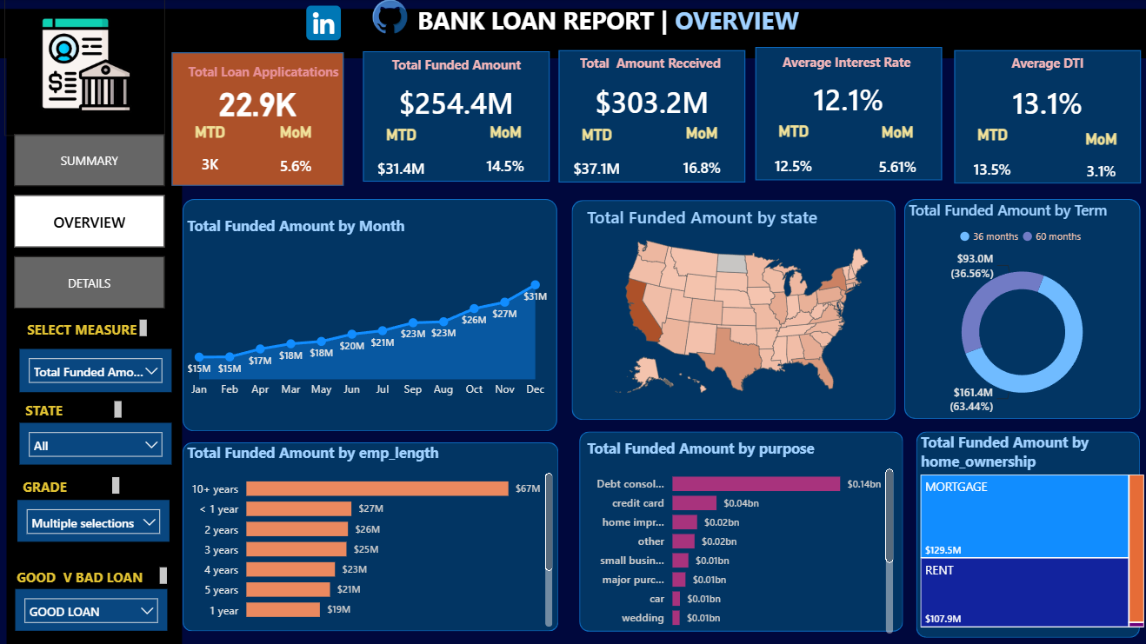
Figure 2 — Overview Page: monthly trend, and breakdowns by state, term, purpose, and home ownership
What it shows
- Monthly trend of applications, funded amount, and amount received across 2021, showing growth trajectory month over month.
- A U.S. map / bar view of loan volume and funded amount by state (all 50 states represented).
- Loan term split (36 months vs 60 months) and its effect on funded amount and collections.
- Breakdown by loan purpose (14 categories, e.g. debt consolidation, credit card, car, home improvement) and by home ownership status (RENT, MORTGAGE, OWN, OTHER, NONE).

6.3 Details Page
The Details page provides a loan-level (record-level) grid view for analysts who need to inspect or export individual applications, complete with borrower, loan, and repayment attributes and filterable by grade, state, or purpose.
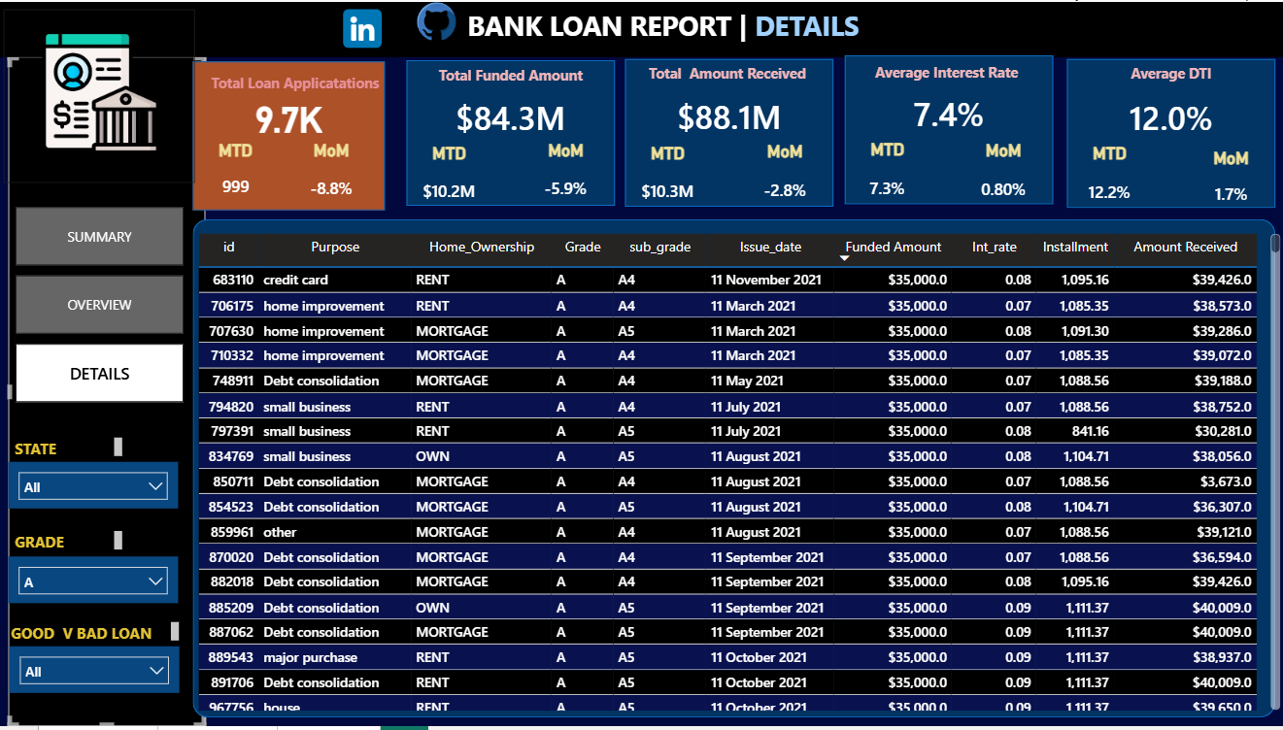
Figure 3 — Details Page: loan-level data grid with borrower and repayment attributes
What it shows
- A tabular, filterable view of individual loan records — id, issue date, borrower state, purpose, term, grade, interest rate, loan amount, and total payment.
- Supports ad-hoc investigation, e.g. isolating all Grade A loans by purpose (a query specifically included in the SQL set for this use case).
- Acts as the audit / drill-through layer beneath the aggregated Summary and Overview pages.

7. Key Insights
- The portfolio is healthy overall: 86.18% of loans are classified "Good" (Fully Paid or Current), against 13.82% Charged Off.
- Charged Off loans destroy value — they recovered only ~57% of the amount funded ($37.28M received vs $65.53M funded), while Good loans recovered more than 100% of principal through interest ($435.79M received vs $370.22M funded).
- Total amount received ($473.07M) exceeds total amount funded ($435.76M) portfolio-wide, indicating the loan book is net profitable before accounting for charge-off losses.
- Average interest rate (12.05%) and average DTI (13.33%) provide a baseline for evaluating risk-adjusted pricing going forward.
- Debt consolidation and credit card refinancing are the dominant stated purposes, consistent with typical unsecured consumer lending patterns.

8. Conclusion
This project demonstrates an end-to-end BI workflow: extracting and validating KPI logic in SQL, then translating that logic into a governed Power BI data model and a three-page interactive report. The resulting dashboard equips decision-makers to monitor lending volume, collection performance, and portfolio risk (Good vs Bad loans) at a glance, while retaining the ability to drill into state-level, purpose-level, and individual loan-level detail. The consistent 86:14 good-to-bad loan ratio and the shortfall in recovery on Charged Off loans are the two findings most relevant to credit policy review.

9. Future Scope
- Add borrower credit-grade trend analysis over time to detect shifts in portfolio risk.
- Incorporate a forecasting model (e.g. time-series) to predict future funded amounts and expected charge-off rates.
- Automate data refresh from a live database instead of a static Excel extract.
- Add a risk-scoring visual that flags states or purposes with above-average charge-off rates.

10. Project Links
Resource | Location
LinkedIn | linkedin.com/in/siddu-data
GitHub | github.com/sidducv0528
Deliverables | Power BI dashboard (.pbix/screens), SQL query set, source Excel data, demo video

